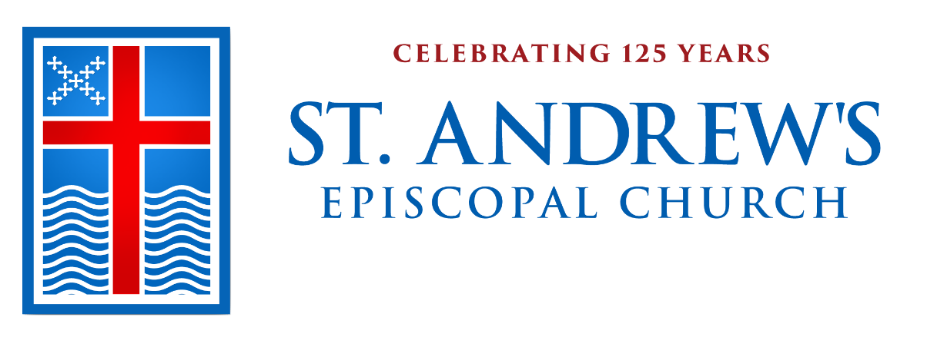
History from our Archives
We hope you will enjoy these timeless items as we journey through our 125th anniversary year, culminating with our celebration in November. With this second Sunday bulletin of 2019, we want to share snippets of history of St. Andrew’s from our beginnings culled from the archives. These snippets will be presented chronologically each month throughout the year for you. This month features items from 1886 to 1900. Any comments or feedback will be appreciated. Thanks.
—Sandra Rigney • sandrig@verizon.net

In 1890 Mrs. Fredonia Case of Wellesley
College wrote to Bishop Benjamin Paddock to petition approval of an Episcopal mission in Wellesley. Mrs. Case spoke for herself, five of her colleagues at the College, five at Dana Hall, and a considerable number of Episcopal students … Together with
Episcopal residents of the town, led by Messrs.’ Lauderburn, Porter, Sawyer, and Tailby, they sought to establish an Episcopal mission within walking distance of the schools and of the homes of townspeople
located mainly on Blossom Street (now
Weston Road), Front Street (now Linden Street), Grove Street, Cottage Street, Brook Street, and Washington Street.

On January 9, 1891 a small group of about thirty persons, mostly women, funded a Mission, identified later with the consent of Bishop Paddock as Saint Andrew’s Church of Wellesley. A senior warden who came from Plymouth, England, where there has been a St. Andrew’s Church since 1087, suggested the name. They also elected Wardens, Vestrymen, and a “lady Clerk” because so few men were present. Steps were taken toward raising money to sustain the Mission, and as a consequence the collection received on Easter Sunday became the seed money for the land and building fund. For the treasurer, the collection of $50.00 was evidence of the Mission’s ability, through faith and hard work, to accomplish this goal.

Second Sunday after the Epiphany
January 13, 2019
Prelude Jesu, joy of Man’s desiring J. S. Bach (1685-1750)
Processional Hymn 448 “O love, how deep, how broad, how high”
Deus tuorum militum
The Word of God
Opening Acclamation Book of Common Prayer p. 355
Celebrant Blessed be God: Father, Son, and Holy Spirit.
People And blessed be God’s kingdom, now and for ever. Amen.
Collect for Purity BCP p. 355
Gloria 96 “Angels we have heard on high” Gloria
Collect of the Day
Celebrant Together we pray.
People Father in heaven, who at the baptism of Jesus in the River Jordan proclaimed him your beloved Son and anointed him with the Holy Spirit: Grant that all who are baptized into his Name may keep the covenant they have made, and boldly confess him as Lord and Savior; who with you and the Holy Spirit lives and reigns, one God, in glory everlasting. Amen.
First Lesson: Isaiah 43:1-7

Thus says the Lord, he who created you, O Jacob, he who formed you, O Israel: Do not fear, for I have redeemed you; I have called you by name, you are mine. When you pass through the waters, I will be with you; and through the rivers, they shall not overwhelm you; when you walk through fire you shall not be burned, and the flame shall not consume you. For I am the Lord your God, the Holy One of Israel, your Savior. I give Egypt as your ransom, Ethiopia and Seba in exchange for you. Because you are precious in my sight, and honored, and I love you, I give people in return for you, nations in exchange for your life. Do not fear, for I am with you; I will bring your offspring from the east, and from the west I will gather you; I will say to the north, “Give them up,” and to the south, “Do not withhold; bring my sons from far away and my daughters from the end of the earth—everyone who is called by my name, whom I created for my glory, whom I formed and made.”

Reader The Word of the Lord.
People Thanks be to God.
Psalm 29 David Hurd
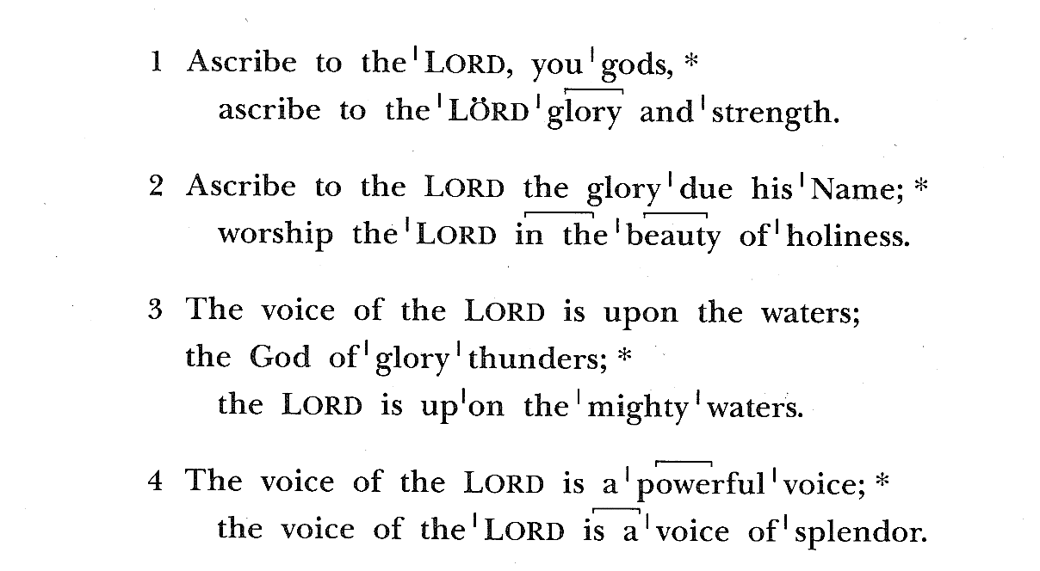
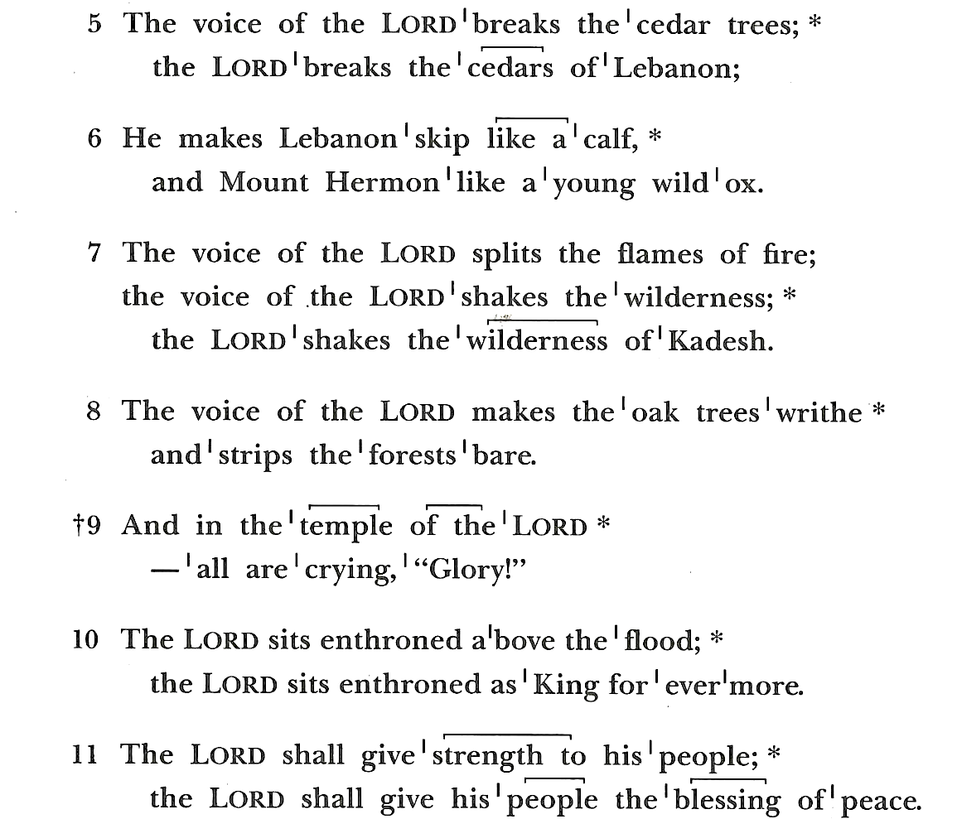
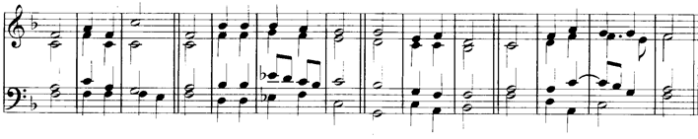
The congregation is encouraged to sing the psalm.
Second Lesson: Acts 8:14-17

Now when the apostles at Jerusalem heard that Samaria had accepted the word of God, they sent Peter and John to them. The two went down and prayed for them that they might receive the Holy Spirit (for as yet the Spirit had not come upon any of them; they had only been baptized in the name of the Lord Jesus). Then Peter and John laid their hands on them, and they received the Holy Spirit.

Reader The Word of the Lord.
People Thanks be to God.
Gradual Hymn 121 “Christ, when for us you were baptized” Caithness
Gospel: Luke 3:15-17, 21-22
Clergy The Holy Gospel of our Lord Jesus Christ, according to Luke.
People Glory to you, Lord Christ.

As the people were filled with expectation, and all were questioning in their hearts concerning John, whether he might be the Messiah, John answered all of them by saying, “I baptize you with water; but one who is more powerful than I is coming; I am not worthy to untie the thong of his sandals. He will baptize you with the Holy Spirit and fire. His winnowing fork is in his hand, to clear his threshing floor and to gather the wheat into his granary; but the chaff he will burn with unquenchable fire.”
Now when all the people were baptized, and when Jesus also had been baptized and was praying, the heaven was opened, and the Holy Spirit descended upon him in bodily form like a dove. And a voice came from heaven, “You are my Son, the Beloved; with you I am well pleased.”

Clergy The Gospel of the Lord.
People Praise to you, Lord Christ.
Sermon Rev. Adrian Robbins-Cole
Nicene Creed BCP p. 358
Prayers of the People
After each bidding the Reader says, Lord, in your mercy.
The People reply, Hear our prayer.

Confession BCP p. 360
Peace
Announcements
Admission of Zebby Dubé, Sarah Harris,
and Caren Parker as new members to the altar guild
Celebrant We are all baptized by the one Spirit into one Body, and given gifts for a variety of ministries for the common good. Our purpose is to commission these persons in the Name of God and this congregation to the special ministry to which they are called as members of the altar guild.
Celebrant Are these persons you present prepared by a commitment to Christ as Lord to exercise this ministry to the honor of God, and the well-being of the Church?
Director I believe they are.
Celebrant You have been called to serve on the altar guild of St. Andrew’s Church. Will you, as long as you are engaged in this work, perform it with diligence?
New Members I will, God being my helper.
Celebrant Will you faithfully and reverently execute the duties of your ministry to the honor of God, and the benefit of the members of this congregation?
New Members I will.
Celebrant Will all of you witnessing this commitment do all in your power to uphold these persons in their ministry among us?
Congregation We will.
Celebrant Let us pray. O God, bless the ministry of these persons and give them grace, that they, caring for the vessels and vestments of your worship and the adornment of your sanctuary, may make the place of your presence glorious; through Jesus Christ our Lord. Amen.

The Holy Communion
Presentation of Bread and Wine
Offertory Anthem “Of the Father’s heart begotten Melody”
from Piae Cantiones (1582)
arr. by David Willcocks(1919-2015),
words by Prudentius (c. 348-413) tr. R.F. Davis (1866-1937)

Of the Father’s love begotten,
Ere the worlds began to be,
He is Alpha and Omega,
He the source, the ending He,
Of the things that are, that have been,
And that future years shall see,
Evermore and evermore!
By His Word was all created
He commanded and 'twas done;
Earth and sky and boundless ocean,
Universe of three in one,
All that sees the moon's soft radiance,
All that breathes beneath the sun,
Evermore and evermore.
He assumed this mortal body,
Frail and feeble, doomed to die,
That the race from dust created,
Might not perish utterly,
Which the dreadful Law had sentenced
In the depths of hell to lie,
Evermore and evermore.
O how blest that wondrous birthday,
When the Maid the curse retrieved,
Brought to birth mankind's salvation
By the Holy Ghost conceived,
And the Babe, the world's Redeemer
In her loving arms received,
Evermore and evermore.
This is He, whom seer and sibyl
Sang in ages long gone by,;
This is He of old revealed
In the page of prophecy;
Lo! He comes the promised Saviour;
Let the world his praises cry!
Evermore and evermore.
Sing, ye heights of heaven, his praises;
Angels and Archangels, sing!
Wheresoe’er ye be, ye faithful,
Let your joyous anthems ring,
Every tongue his name confessing,
Countless voices answering,
Evermore and evermore.

Doxology Hymn 380 v. 3 “Praise God from whom all blessings flow” Old 100th
Eucharistic Prayer B BCP p. 367
Sanctus S130 (front section of hymnal) Franz Schubert (1797-1828)
Breaking of the Bread
Fraction Anthem S164 (front section of hymnal) Franz Schubert
Ushers will direct the congregation to communion stations, starting
from the rear of the church and moving forward. Gluten-free wafers are
available. All are welcome to receive communion.
Communion Anthem Asperges me Anton Bruckner (1824-1896)
Purge me with hyssop, and I shall be clean: wash me, and I shall be whiter than snow.
Have mercy upon me, O God, according to thy loving kindness.
Glory be to the Father, and to the Son, and to the Holy Ghost.
As it was in the beginning, is now, and ever shall be, world without end. Amen.
Communion Hymn 294 “Baptized in water” Point Loma
Thanksgiving after Communion BCP p. 365
Blessing
Recessional Hymn 616 “Hail to the Lord’s Anointed” Es flog ein kleins Waldvögelein
Dismissal
Clergy Go in peace to love and serve the Lord.
People Thanks be to God.
Postlude Der Tag, der ist so freundenreich J. S. Bach

Please join us for refreshments following the 10am service,
hosted today by the Mahoney and Eikeboom families.

Serving St. Andrew’s this week
Altar Guild D.D. Alexander, Dell Beggs, Terri Burnell, Jean Childs, Elizabeth Clarke, Caren Parker, Cynthia Scott, Carol Sullivan, and Liz Tecca
Flowers St. Andrew’s Flower Guild

Serving at 8am
Lay Reader/Chalice Bearer Nancy Echlov
Ushers Nancy Kohl & Bob Ware

Serving at 10am
Acolytes Elizabeth Robbins-Cole, Henry MacKinnon, Miles Olivetti,
Annika Svedlund, and Sterling Williams
Chalice Bearers Joe Hamilton, Eliot Heher, Debbie Lorenz, and Margaret Zusky
Greeters Anne Manners
Lay Readers Madison Riley, Nora Tracy Phillips, and Randy Parker
Ushers David Boghosian, Giles Boland, Tim Phillips, Larry Scott, and Paul Zusky

Intercessions from the Diocesan Cycle of Prayer
Parishes of the Boston Harbor Deanery
Emmanuel Church, Boston
St. Augustine’s & St. Martin’s Church, Boston
Deans
Deanery Coconveners
Greater Boston Interfaith Organization

About the Readings

Isaiah 43:1-7 In the second half of the book of Isaiah, the prophet proclaims a message of consolation and encourage-ment. Today’s reading reminds the people that the same God who created and punished Israel has now redeemed Israel. The suffering that Israel exper-ienced in captivity did not change God’s love and devotion to Israel.
Psalm 29 Psalm 29 is a hymn to Yahweh as the God of storm. It may have been written as an objection to the pagan assertion of Baal as the thunder-god. Yahweh alone exercises dominion over nature and over all gods and so is the source of strength and blessing for the people.
Acts 8:14-17 In the reading, the gospel penetrates a new field of ministry: Samaria. As Jesus promised before his ascension, the disciples’ testimony would fill Jerusalem and Judea, and would then penetrate Samaria on its way “to the ends of the earth” (1:8). Philip, one of the seven ministers or “deacons” appointed by the Church in Jerusalem to serve in the distribution of the food, fled the persecution that arose upon Stephen’s martyrdom. When he arrived in Samaria, he “proclaimed the Messiah” (8:5), and the news was received with joy. The Jerusalem church, which oversaw the spread of the gospel, sent Peter and John to confirm the creation of a new Christian community. The Holy Spirit authenticates this new mission through another outpouring similar to Pentecost.
Luke 3:15-17, 21-22 Like Mark and Matthew, Luke records John’s denial of his own importance. It is the mightier one who is coming who will baptize with the Holy Spirit and with fire. Jesus is baptized along with “all the people” (v. 21), identifying himself with those who acknowledge their sins. As Jesus was praying (in Luke often a prelude to major events), the Holy Spirit descends. With the title formerly applied to the nation, to the king and later to the Messiah, Jesus is now openly called the Son of God, dramatizing and confirming what was implicit in his conception (1:35). Thus Jesus is anointed for his mission.

Notices & Announcements
Newcomers and visitors: We extend a warm welcome to those who
are new in our community. Please fill out one of the welcome cards
in the narthex (foyer) and hand it to a greeter for a fuller welcome!

A Note from the Treasurer's Office
Offering envelopes for 2019 are available at the back of the church. If you would like envelopes and have not ordered them, please contact me in the treasurer's office.
— Ruth Hubert • 781/235-7310
• ruth@standrewswellesley.org
Church School and Junior Choir
Confirmation prep and youth group (grades 8-12) resumes today, Sunday, January 13. Kids’ Place, church school, Rite-13 (grades PK-seven) and Junior Choir will resume on Sunday, January 27. — Rev. Catherine Healy • catherine@standrewswellesley.org
Anna Page, Seminarian
We are delighted to welcome our seminarian, Anna Page, as our guest preacher and adult education lecturer on Sunday, January 20. Anna graduated from Wellesley College in 2018 and is now a graduate student at Duke Divinity School. She is a commissioned chaplain candidate in the U.S. Army and, with the sponsorship of St. Andrew’s, is preparing for ordination to the priesthood in the Episcopal Church. Welcome back, Anna! — Rev. Catherine Healy
• catherine@standrewswellesley.org
Budget Forum
There will be an opportunity for parishioners to learn about the 2019 parish budget for St. Andrew’s at a forum at 11:30am Sunday, January 20 in Room 2. This forum will be led by Alan Joachim, the head of the finance committee. The rector and wardens will also be present to answer any questions. The final budget will be presented at the annual meeting on January 27, after it has been approved by the vestry at its meeting on
January 22. All are welcome.
— Rev. Adrian Robbins-Cole
• adrian@standrewswellesley.org
MLK Day of Action
Live out the legacy of Martin Luther King, Jr. through the MLK Day of Action! On Mon-day, January 21, 2019, volunteers will gather at St. Andrew's to drive into Boston and spend the day (approximately 9am to 2pm) working on projects at the Blackstone School, a partner of St. Stephen's Church, our sister parish. All ages are invited; children below grade nine should bring a parent. See the sign-up genius on the serve page of the website. — Cam McCormick
• cammccormick@earthlink.net
Martin Luther King Day Breakfast
St. Andrew’s will be sponsoring a table at the annual MLK breakfast again, hosted by the World of Wellesley. The speaker will be Claudia Fox Tree who will talk about
Native American culture and history. The Kuumba Singers of Harvard College and the Wellesley High School Step Dancers will perform. The breakfast is 8 to 10am on
Monday, January 21, at Mass Bay Community College, 50 Oakland St, Wellesley. If you would like to go to the breakfast and represent St. Andrew’s, please let me know. — Rev. Adrian Robbins-Cole
• adrian@standrewswellesley.org
Salvation Army/Pearl Street
Cupboard & Café
St. Andrew’s is committed to providing six volunteers for two hours (5:15 to 7:15pm) every fourth Tuesday of the month to help serve a meal to the needy in Framingham. Our next opportunity to serve is Tuesday, January 22. Sign up by visiting the church website and clicking on serve and then on volunteer sign-up. — Tim Phillips
• timphillips59@yahoo.com
Annual Meeting
The 126th annual meeting will be held from 11am to 12:30pm on Sunday, January 27. New parish leaders will be elected, reports will be given on the work accomplished in 2018, and a budget for 2019 will be presented. Please save this date.
— Rev. Adrian Robbins-Cole
• adrian@standrewswellesley.org
New Members Wanted!
Would you like to have a part in working behind the scenes at St. Andrews? Please consider your local Altar Guild. Training is necessary, but subject to your own schedule. Volunteer time is once a month, within a team of experienced members and friends. Serving on Altar Guild is rewarding, communal, contemplative, useful and spiritual. Come join us in setting up these Holy
Mysteries. Please contact Laura Brown
MacKinnon laura@brown-mackinnon.com or Elizabeth Parsons epparsons@mac.com if you are interested.
Lay Readers
The Scripture readings are an important part of our worship services. Reading is a popular ministry for many in our congregation, and we would like to invite new members to join our group of readers. Joe Hamilton coordinates our lay ministers and would love to include you in the next scheduling cycle starting in March. Please let Adrian adrian@standrewswellesley.org or Joe
Hamilton porlier@outlook.com know if you are interested.
Nametags
Nametags are a great way to get to know folks and help everyone feel welcome. The membership committee offers lovely reusable magnetic nametags for all members. If you would like a new or replacement name tag, please contact me. — Becky Hamlin
• dbhamlin@comcast.net
“Refreshing” the Parish Prayer List
Praying for our loved ones at times of need is a central part of our worship and church life. We would like to remind you that at the beginning of every season, we “refresh” the prayer list. We remove names of people for whom we have been asked to pray if we have not heard that you wish us to keep your loved one on the list for the next season. We are happy to keep people on the list for as long as they are in need of our prayers. However, our proactive approach helps prevent a buildup of people on the list after the need for our prayers for that person has passed. Thanks for your help with this.
— Rev. Adrian Robbins-Cole
• adrian@standrewswellesley.org
Firearm Safety Task Force
The Firearm Safety Task Force met on Sunday, December 9, and adopted the following Mission Statement:
St. Andrew's Firearm Safety Task Force is a non-partisan group committed to educating the congregation on relevant common sense gun legislation at both the local and national level. The committee strives to provide guidance to interested parishioners on how to become involved faithfully in decreasing gun
violence and promoting gun safety. In addition we pledge ourselves to bring the values
of the gospel to affirm the sacredness of every human life.
The Task Force will meet again on
Sunday, February 3, at 11:30am in Room 2. We are working on preparing a forum to the parish this winter. — Paul Merry
• paul.merry@fairworkplace.net
B-READY Lunch Prep
Please join us in the parish hall kitchen as we prepare a meal for St. Stephen's B-READY program on Sunday, February 3. The hungry kiddos show up at the church about 3pm and are very happy when they have a hot meal to tide them over while they work on homework and enrichment activities. We meet in the kitchen right after the 10am service and are usually done by 1:30pm. Please email me if you can help.
— Cam McCormick
• cammccormick@earthlink.net
Deadlines for Weekly Bulletin
and e-Pistle Announcements
Announcements and gratitudes (and anything else) for inclusion in the weekly bulletin or e-Pistle are due on Tuesdays at noon. Please limit your announcement to 50-100 words. — Katharine Clark
• kate@standrewswellesley.org
Social Media
St. Andrew’s has been using social media for a while. We have an Instagram and a Twitter account both at the same address: @StAsWellesley, and we have a Facebook account: @StAndrewsWellesley. We encourage you to find and follow us on any or all of these platforms. Have fun. Spread the word. Post pics from your meetings and work here at church. We want to see what you are doing. — Katharine Clark
• kate@standrewswellesley.org

Gratitude
B-READY Lunches
A big thank you to the volunteers who cooked and delivered a meal for B-READY, the after school program at our sister parish St. Stephen's, on January 6: Bonnie Akins, Heidi Harper, Carol Jankowski, Cam McCormick, Llynda McFarlane, and Debbie Osborn. Another big shout out to Mary Scanlon & Victor Calcaterra, who noticed when we did this cooking in December, that one of our cooking pots had broken handles. They found a welder to repair the pot, saving us from discarding an otherwise useful item or purchasing another one. Many thanks for your initiative!
Epiphany Fireside
Thank you to everyone who attended the lovely Epiphany Fireside Service & Potluck dinner this past Sunday. Your wonderful selection of appetizers, salads and desserts nicely complemented our homemade soup and baked potato bar. A special thank you to the following people for preparing, setting up, serving, and cleaning up a delightful meal: Barbara Bergstrom, Al & Zebby Dubé, Marie Dunell, Becky & David Hamlin, Nancy Jones, Linda Lull, Michael Mahlenkamp, Paige Manning, Jen Martin, Jen Olivetti, and Sandy Rigney. Hope to see you all at the next potluck on January 27!

Vestry

Adult Formation Peter Fergusson
Clerk Sarah Harris
Communications Peter Lull
Fellowship Jenny Sawyer
Finance Alan Joachim
Human Resources Frank Hunnewell
Membership Suzanne Nystrom
Outreach Heidi Harper
Property Jim Blackwell
Stewardship Allen Jones
Treasurer Arnout Eikeboom
Wardens Michael Vanin
David Hamlin
Worship Cynthia Scott
Youth Formation Jen Martin

Staff
The clergy are always available to assist you. Please email or call the clergy if you
or a member of your family expects to be in the hospital and wishes to be visited.
Also, please let us know of names that should be added to our prayer list.
Our prayers and concerns are with all those in need.

Rector The Rev. Adrian Robbins-Cole adrian@standrewswellesley.org
Associate Rector for Adult Formation and Membership
The Rev. Margaret Schwarzer margaret@standrewswellesley.org
Assistant Rector for Youth and Family
The Rev. Catherine Healy catherine@standrewswellesley.org
Pastoral Associate The Rev. Karen Vickers Budney revkar7@comcast.net
Parish Administrator Katharine L. Clark kate@standrewswellesley.org
Music Minister Helen Ward Mannix wardie@standrewswellesley.org
Financial Secretary Ruth Hubert ruth@standrewswellesley.org
Christian Learning Coordinator Susan Jackson susan@standrewswellesley.org
Director of Youth Choirs Amanda Kern amanda@standrewswellesley.org
Sexton Steve Killeen steve@standrewswellesley.org
Assistant Sextons Bill Clover and Matthew Killeen
Weekly Calendar
- The Holy Eucharist is celebrated on Sundays at 8am, 10am and 5pm. The Holy
Eucharist is also celebrated every Wednesday at 7:30am—we offer healing prayer
at this service; Silent Contemplative Prayer is also offered weekdays at 8:45am,
unless otherwise noted.
- Senior Choir rehearsal is on Thursdays at 7:30pm, and Sundays at 9am; Junior Choir rehearsal is on Sundays at 9am.
- Parish Office hours are Monday through Thursday, 9am to 5pm,
and Friday, 9am to 12pm.
- 12-Step Programs Al-Anon, Tuesdays, 7:30pm; Men’s AA, Wednesdays, 8pm;
Women’s AA, Thursdays, 7pm; Emotions Anonymous, Saturdays, 9:30am;
Step Sisters, Saturdays, 10:30am.

Sunday, January 13
See service schedule above
5pm Confirmation
6:45pm Youth Group
Wednesday, January 16
7pm Worship Committee
Thursday, January 17
11am Holy Eucharist at North Hill
Sunday, January 20
See service schedule above
11:30am Budget Forum


